BIVARIAATE ANALYSIS

- Which Restaurant Has Received the highest and Lowest Number of Vote?
Answer:

- Restaurant Name Toit
- Votes 10934

- The dataset has a column for votes (how many people rated a restaurant).
- The restaurant with the highest number of votes is Toit with 10,934 votes.

- Restaurant Name Cantinho da Gula
- Votes 0

- The restaurant with the lowest number of votes is Cantinho da Gula with 0 votes.
- So, Toit is the most voted restaurant, while Cantinho da Gula has no votes at all.

- How Many Votes Received Din Tai Fung?
Answer:

- In the dataset, Din Tai Fung received 336 votes.
- Another entry shows 661 votes.

- So, Din Tai Fung has two entries in the dataset:
- One with 336 votes
- Another with 661 votes

- What Are the Top 5 Most Voted Restaurant?
Answer:

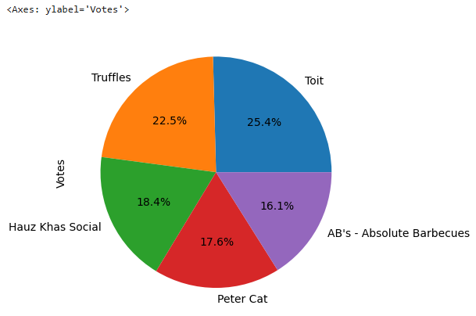

- Top 5 most voted restaurants are:
- Toit → 25.4% of total votes (highest)
- Truffles → 22.5%
- Hauz Khas Social → 18.4%
- Peter Cat → 17.6%
- AB’s – Absolute Barbecues → 16.1%
- So, Toit is the most voted restaurant, followed by Truffles.

- Are There Any Restaurant With 0 Vote?

Answer:

Restaurant Name | Votes
- Cantinho da Gula 0

- The Chaiwalas 0
• Fusion Food Corner 0
- Punjabi Rasoi 0

- Baskin Robbin 0

- So, many restaurants in the dataset exist but have never received any votes.

- Which City Has the Restaurant with The Highest and Lowest Number Vote?
Answer:

- City Bangalore
- Restaurant Name Toit
- Votes 10934

- The restaurant with the highest number of votes is Toit.

    - City: Bangalore
    - Votes: 10,934.

- So, Bangalore has the restaurant with the highest votes, and São Paulo has the restaurant with the lowest votes.

- What Is the Average Number of Vote Per Restaurant in Each City?
Answer:

Average Number of Votes per Restaurant (by City)

- City

- Bangalore 2805.75
- Kolkata 2229.65
- Mumbai 1484.85
- Chennai 1384.75
- Tampa Bay 1370.35
      - ...
- Miller 11.00
- Brasí_lia 10.85
- Potrero 9.00
- Consort 6.00
- Cochrane 6.00

- The city with the highest average votes per restaurant is Bangalore.

- The cities with the lowest average votes per restaurant are Consort and Cochrane.

- Which City Has the Most Restaurant with More Than 100 Vote?
Answer:

- City with the Most Restaurants Having More Than 100 Votes

  - City: New Delhi
  - Number of Restaurants: 1167

- New Delhi has the highest number of restaurants where each restaurant has received more than 100 votes.

- List The Top 5 Cities Based on Total Votes From All Restaurant?

Answer:

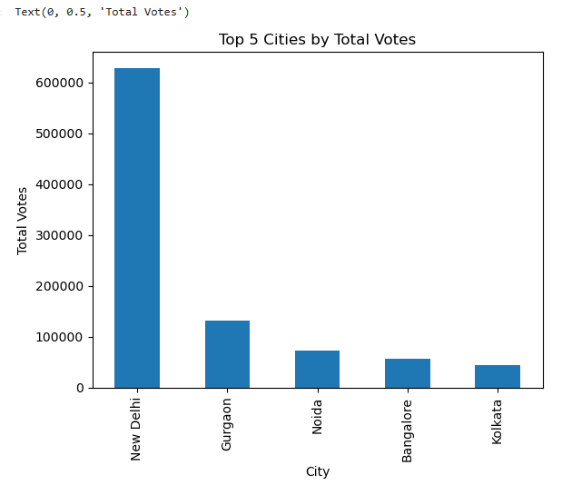

- Top 5 Cities by Total Votes are:
• New Delhi – by far the highest, crossing 600,000+ total votes.
• Gurgaon – second place, with votes around 130,000.
• Noida – third place, votes around 75,000–80,000.
• Bangalore – fourth place, slightly less than Noida.
• Kolkata – fifth place, with the lowest among the top 5 (around 40,000–50,000).

- New Delhi dominates the list with much higher total votes than all other cities combined.

- List All Cuisines Where The Average Cost For Two Less Than 500?

Answer:

- cuisines where the average cost for two people is less than 500.

- African → Avg cost = 450
- African, Portuguese → Avg cost = 160
- American → Avg cost ≈ 188
- American, Asian, Burger → Avg cost = 40
- American, BBQ → Avg cost = 17.5
- Vietnamese, Fish and Chips → Avg cost = 40
- There are many cuisines (single and combined types) where the average cost for two people is less than ₹500, including African, American variations, Vietnamese, World Cuisine mixes, etc.

- Which Restaurant Has The Highest Rating And Highest Vote?
Answer:

    - Restaurant with the highest rating (4.9) → Ooma

    - Restaurant with the highest votes (10,934) → Toit

- This means the highest-rated restaurant and the most-voted restaurant are different:

      - Ooma stands out for quality (rating).

      - Toit stands out for popularity (votes).

- restaurant that has both a very high rating and very high votes together .

11)Are There Restaurant With High Rating But Low Number Of Vote?
Answer:

- There are several restaurants that have very high ratings (4.5 – 4.9) but a low number of votes .

• Coco Bambu → Rating 4.9, but only 30 votes
• Confeitaria Colombo → Rating 4.8, only 29 votes
• TT Burger → Rating 4.8, just 19 votes
• Bibi → Rating 4.7, only 24 votes
• Sushi Leblon → Rating 4.6, just 25 votes
- These restaurants are rated excellent by the few people who voted, but they don’t have enough votes to show broad popularity.

- They may be hidden gems or lesser-known places.

12)What Is The Total Number Of Vote For Each Rating Category?
Answer:

- Aggregate rating

- 1.8 322
- 1.9 212
- 2.0 908
- 2.1 1146
- 2.2 2564
- 2.3 3281
- 2.4 8440
- 2.5 8764
- 2.6 10299
- 2.7 13094
- 2.8 10003
- 2.9 6709
- 3.0 9432
- 3.1 16693

- total number of votes per rating category (aggregate rating).

- Total Votes by Rating Category

  - Lowest Rating (0.0 – 2.0):

- Very few votes compared to higher ratings. Example: 0.0 → 1,869 votes, 2.0 → 908 votes.
- This means restaurants rated poorly don’t attract many votes.

- Moderate Ratings (2.1 – 3.0):

- Votes increase as ratings improve. Example: 2.7 → 13,094 votes, 2.9 → 6,709 votes, 3.0 → 9,432 votes.

- Most Popular Rating Range:

- Around 2.5 to 3.1, where votes are highest.
- Peak = 3.1 rating with 16,693 votes.

13)Which Rating Text Is Most Common In Dataset?
Answer:

Most Common Rating Text in Dataset
- Rating Text: "Average"

- This means most restaurants in the dataset are rated as neither too bad nor too excellent, just in the middle range.

- It shows that "Average" restaurants are the most common category compared to "Good," "Excellent," "Poor," etc.

14)How Many Restaurant Have 0 Vote But Received ‘Very Good’ Rating?
Answer:

- Restaurants with 0 Votes & "Very Good" Rating

- Number of restaurants: 0

- This means every restaurant that has received a “Very Good” rating has at least 1 vote.

- So, no restaurant is marked “Very Good” without customer feedback.

15)Which Rating Text Has The Least Number Of Total Vote?
Answer:

- Rating Text with the Least Number of Total Votes

  - Rating Text: "Not rated"
  - Total Votes: 1,869

- This means these restaurants have a rating label but very few people actually voted for them.

- "Not rated" restaurants are the least popular in terms of votes.

- Most customers prefer voting for restaurants that already have a proper rating like "Average," "Good," or "Very Good."

16)Which Rating Color Category Has The Highest Average Cost For Two?
Answer:

- Rating Color with Highest Average Cost for Two

- Rating Color: Dark Green

- Average Cost for Two: ₹8136.61

- This means restaurants with a Dark Green rating color (which usually represents excellent ratings) are the most expensive on average.

- High rating (Dark Green) is linked with premium restaurants.

- Customers usually pay more at these places because they offer top-quality food, service, and experience.

17)What Is The Minimum And Maximum Average Cost For Two Per Rating Color?
Answer:

- Minimum & Maximum Average Cost for Two per Rating Color

Rating Color | Minimum Cost | Maximum Cost
Dark Green 0 800,000
Green 0 800,000
Orange 0 100,000
Red 10 2500
White 20 3,000
Yellow 0 300,000

- Dark Green & Green → Very wide range (₹0 to ₹8,00,000). Some restaurants are super premium.
- Orange → Moderate range (₹0 to ₹1,00,000).
- Red → Lowest spread (₹10 to ₹2,500), usually cheap restaurants.
- White → ₹20 to ₹3,000, also relatively low.
- Yellow → ₹0 to ₹3,00,000, middle to high range.

- The highest maximum cost is in Dark Green & Green (₹8,00,000).
- The lowest minimum cost (₹0) is seen in most categories.
- Red & White categories represent budget-friendly places.

18)How Many Restaurant With Cost Below 500 Are Rated ‘Orange’?
Answer:

- Restaurants with Cost Below 500 & Rating Color = Orange
- Number of Restaurants: 1954
- Condition:
- Average cost for two < 500
- Rating color = Orange

- Many budget-friendly restaurants (under ₹500) are rated Orange, which usually means Average quality.

- So, a large number of affordable restaurants fall into the average rating category.

19)How Many Unique Restaurant Are There In Dataset?
Answer:

Unique Restaurants in the Dataset
- Total Unique Restaurants: 7446
- This means even if some restaurants appear multiple times in the data, after removing duplicates we get 7446 different restaurant names.

- The dataset covers a large variety of restaurants.

- Some restaurants repeat across different cities/branches, but 7446 are distinct.

20) Which Cuisines Are Most Commonly Sereved By Restaurant?

Answer:

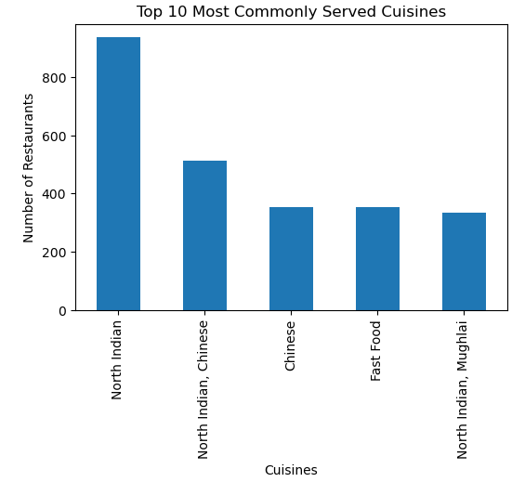

- Top 5 most commonly served cuisines by restaurants:

- North Indian – highest number of restaurants.
- North Indian, Chinese – combination cuisine, very popular.
- Chinese
- Fast Food
- North Indian, Mughlai

- So, the most common single cuisine is North Indian, and the most common combination cuisine is North Indian & Chinese
21)Which Restaurant Offer Wide Variety Of Cuisines?
Answer:

- The restaurant that offers the widest variety of cuisines in your dataset is:

- Restaurant Name: Bikanervala

- Cuisines Offered: North Indian, South Indian, Fast Food, Street Food, Mithai, Chinese, Beverages, Continental

- Cuisine Count: 8

- That means Bikanervala has the largest spread of cuisine options compared to other restaurants in the dataset.

22)Which Restaurant Serve Both Indian And Chines Cuisines?
Answer:

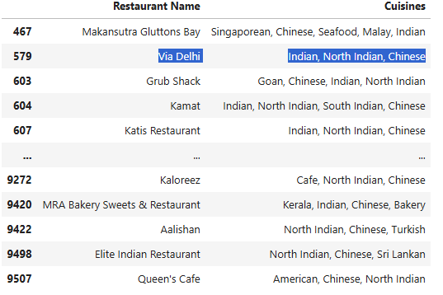

- there are multiple restaurants serving both Indian and Chinese cuisines.

- Makansutra Gluttons Bay → Singaporean, Chinese, Seafood, Malay, Indian
- Via Delhi → Indian, North Indian, Chinese
- Grub Shack → Goan, Chinese, Indian, North Indian
- Kamat → Indian, North Indian, South Indian, Chinese
- Katis Restaurant → Indian, North Indian, Chinese
- Kaloreez → Cafe, North Indian, Chinese

- These all qualify since they include Indian (North/South/General) and Chinese together in the cuisines.

23)Are There Any Restaurant Serve Only One Cuisines?
Answer:

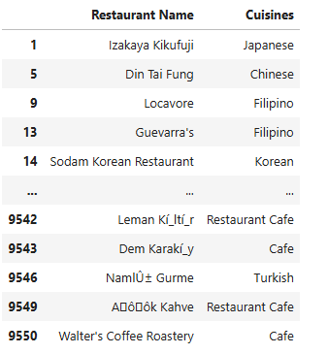

- This table shows restaurants that serve only one cuisine.

Explanation:

  - Restaurant Name → The name of the restaurant.
  - Cuisines → The cuisine(s) the restaurant offers.

- This chart is basically an extract proving that yes, there are many restaurants in the dataset that serve just one type of cuisine, such as Japanese, Chinese, Filipino, Korean, Turkish, or Cafe.

24) How Many Unique Restaurant Are There In Each City
Answer:

- City

- Abu Dhabi 20
- Agra 20
- Ahmedabad 21
- Albany 20
- Allahabad 20
- Weirton 1
- Wellington City 20
- Winchester Bay 1
- Yorkton 1
- ÛÁstanbul 14

- showing the number of unique restaurants available in each city from your dataset.

- This means the dataset contains different restaurant counts per city, with some big cities having hundreds or thousands, while smaller ones or less-represented ones have just 1 or a few.

25)Which City Has Highest Number Of Restaurant Listed?
Answer:

- The city with the highest number of restaurants listed in your dataset is:
- New Delhi with 5473 restaurants.

- This indicates that New Delhi dominates the dataset, having far more restaurants listed than any other city.

26)Are There Restaurant Name Appear In Multiple Cities?
Answer:

- Yes there are restaurant names that appear in multiple cities.

10 Downing Street → appears in 2 cities
A Piece of Paris → 2 cities
AB's - Absolute Barbecues → 3 cities
Aapki Rasoi → 2 cities
Aggarwal Sweet Corner → 2 cities
Zaffran → 2 cities
Zaika → 2 cities
Zaika Kathi Rolls → 2 cities
Zizo → 3 cities
Zooby's Kitchen → 2 cities

- This means some restaurant chains/brands are present across different locations, not limited to just one city.

27)Which City Has Most Restaurant With Same Name?
Answer:

- New Delhi has the most restaurants with the same name → 1178 occurrences.

- That means in New Delhi, there are 1178 restaurants where names are repeated (chains, duplicates, or common brand outlets).

28)Which Cuisines Has Highest Rating?
Answer:

- Cuisines American, BBQ, Sandwich

- Aggregate rating 4.9

- Cuisine with the highest rating: American, BBQ, Sandwich

- Highest aggregate rating: 4.9

- Restaurants serving American + BBQ + Sandwich cuisines got the best rating in the dataset.

29)How Many Cuisines Have An Average Rating above 4.0?
Answer:

- Number of cuisines with average rating > 4.0 → 486 cuisines

- This means out of all cuisines in the dataset, 486 different cuisine types are rated above 4.0

30)Is There Any Cuisines With Mostly Low Rating Below 3.0?
Answer:

- “Orange” rating color corresponds to ratings between 2.5 and 3.4, which are considered Average/Low ratings.

- 3737 cuisines fall under the Orange category, meaning these are cuisines/restaurants that mostly have ratings below 3.0 or around average.

